**Project Documentation: CRM Application for Wholesale Rice Mill**

Enhancing Rice Mill Efficiency with Salesforce Integration

Prepared by: Gourav Sen

**Table of Contents**

1. **Introduction**
2. **Project Overview**
3. **Features and Functionality**

* ***Reporting and Dashboards***
* ***Rollup Summary Field***
* ***Cross-Object Formula Field***
* ***Validation Rules***
* ***Permission Sets and Roles***

1. **Prerequisites**
2. **Project Implementation Steps**

* ***Introduction to Salesforce***
* ***Object Creation***
* ***Tabs Creation***
* ***The Lightning App***
* ***Field Creation***
* ***Page Layouts***
* ***Profiles and Roles***
* ***Users and Permission Sets***
* ***Reports and Dashboards***
* ***Apex Development***

1. **What I Gained from the Project**
2. **Conclusion**
3. **Future Enhancements**

**1.** **Introduction**

This document outlines the development of a CRM application specifically designed for a wholesale rice mill. Managing a rice mill involves numerous tasks such as purchasing raw rice, processing it, handling sales, maintaining customer satisfaction, and ensuring smooth operations. This can be overwhelming, especially when aiming to grow the business and stay competitive.

The **Rice Mill CRM Application** is created to simplify the rice milling process for everyone involved, whether you are the owner, an employee, or a customer. This tool streamlines daily activities, allowing you to focus on producing quality rice and delivering it to those who need it.

Consider this CRM application as your comprehensive assistant. It tracks everything from daily rice sales to customer preferences in real-time, providing up-to-date insights for smarter decision-making.

No more sifting through spreadsheets or guessing your next move. With this application, all necessary information is readily available. Want to check today’s revenue? It’s just a click away. Need to know which type of rice is most popular? The dashboard has the answer.

Beyond numbers and reports, the success of a rice mill hinges on relationships with suppliers, customers, and team members. This application enhances relationship management, ensuring everyone receives the attention they deserve.

Designed to be user-friendly, this CRM requires no technical expertise. Whether you’re new to digital tools or already tech-savvy, it integrates seamlessly into your workflow, simplifying your job without a steep learning curve.

As your business expands, this application evolves with you. It’s flexible, customizable, and ready to tackle new challenges. Whether you aim to improve efficiency, boost customer satisfaction, or better manage daily operations, the Rice Mill CRM Application supports your goals.

In essence, this project equips you with the tools needed to run a successful rice mill, prepared for the future and capable of thriving in a competitive market.

**2.** **Project Overview**

The Rice Mill CRM Application is designed to assist anyone involved in the operation of a rice mill. Whether you’re an owner, manager, or team member, this application simplifies and organizes your daily tasks. Its primary goal is to streamline the management of the rice mill, from tracking daily rice production and sales to monitoring customers and their preferences.

**Why This Application Matters**

Managing a busy rice mill can be overwhelming. From ensuring there's enough rice to process, to recording sales accurately, and keeping customers happy, there's a lot to manage. This is where the Rice Mill CRM Application comes in—it acts like an extra set of hands (or even a whole team) to help manage operations. It centralizes everything in one place, ensuring important details aren't missed. Whether you're checking today’s rice sales or reviewing a customer's order history, the information is readily accessible and easy to use.

**Key Features**

* **Daily Sales Tracking**: The application offers real-time tracking of daily sales, showing how much rice was sold, which types are popular, and total revenue. This data helps you make quick, informed decisions to enhance your business.
* **Customer Management**: The application stores all customer data in one place, making it easy to track preferences and purchasing habits. This enables better customer service and stronger relationships.
* **Easy Reporting**: Generating reports on sales, revenue, and key metrics is straightforward. The reports are easy to interpret and share, supporting informed decision-making.
* **User-Friendly Design**: The application is intuitive and easy to use, requiring no special training—just log in and get started.

**Benefits for Your Business**

The Rice Mill CRM Application saves time and reduces stress by centralizing critical information. You won’t have to worry about missing important details or spending hours searching for data. Instead, you can focus on growing your business, improving customer satisfaction, and increasing efficiency. The application is also scalable and can be customized to fit your evolving needs, with the flexibility to add new features or integrate with other systems.

**3.** **Features and Functionality**

**Reporting and Dashboards:** The application excels at generating detailed daily reports covering key aspects such as rice sales, total income, popular rice types, and customer purchases. These insights help rice mill owners make data-driven decisions, optimizing resource allocation and planning for growth. By understanding product demand and top customers, the mill can fine-tune operations and drive success.

**Rollup Summary Field:** One powerful feature is its ability to summarize data from related records and display it on the parent record. For instance, the total rice supplied by each supplier is automatically calculated and displayed on the supplier’s record. This provides up-to-date inventory and supplier contributions, eliminating the need for manual calculations.

**Cross-Object Formula Field:** This feature enables automated calculations across different objects within Salesforce. For example, the application automatically calculates the total payment due from a consumer based on the quantity purchased and the price per kilogram. This reduces manual errors and ensures accurate payment tracking for both the consumer and the rice mill.

**Validation Rules:** To maintain data integrity, validation rules prevent saving records with missing or incorrect information. For example, if a required field is left blank, a validation rule with the ISBLANK function prompts the user with an error message. This ensures that all necessary information is entered correctly, keeping the database accurate and reliable.

**Permission Sets and Roles:** The application includes a robust system for managing user access through permission sets and roles. Organization-Wide Default (OWD) settings restrict access by default, ensuring data security. Roles such as Owner, Employer, and Worker are defined, with varying levels of access: Owners can view all records, Employers can view Worker records, and Workers have more limited access. This ensures that sensitive data is only accessible to those with the appropriate permissions, while still allowing users to perform their tasks efficiently.

**4.** **Prerequisites**

To ensure a smooth start with the Rice Mill CRM Application, here’s what you’ll need:

1. **Salesforce Developer Account**
   * **What It Is**: A Salesforce Developer Account is necessary for building and customizing the CRM application. It provides access to all the tools and resources required for setup and customization.
   * **How to Get It**: If you don’t already have one, you can sign up for a free Salesforce Developer Edition account. It’s a quick and simple process!
2. **Basic Knowledge of Salesforce Admin Concepts**
   * **Why It Matters**: A basic understanding of Salesforce administration is essential, including how to set up objects, fields, relationships, and manage permissions.
   * **What to Brush Up On**:  
     ▪ Creating and managing objects and fields  
     ▪ Designing page layouts and record types  
     ▪ Setting up permission sets and roles  
     ▪ Using validation rules and formula fields
3. **Web Browsers**
   * **What You Need**: Ensure you have at least two web browsers installed for accessing Salesforce and testing the application.
   * **Recommended Browsers**: Google Chrome, Mozilla Firefox, or Microsoft Edge are ideal for compatibility and performance.
4. **Good Internet Connectivity**
   * **Why It’s Important**: A stable and fast internet connection is crucial for a smooth Salesforce experience and to keep things running efficiently.
   * **What’s Ideal**: Aim for an internet speed of at least 5 Mbps to prevent any disruptions.
5. **Basic Understanding of CRM Systems**
   * **What It Helps With**: Having general knowledge of CRM systems will make it easier to use the application and understand its features.
   * **Topics to Know**:  
     ▪ What CRM systems are and their importance  
     ▪ Common features and benefits of CRM tools
6. **Familiarity with Reporting and Dashboards**
   * **Why It’s Useful**: Knowing how to create and interpret reports and dashboards will help you maximize the insights provided by the application’s data.
   * **What to Review**:  
     ▪ Creating and customizing reports  
     ▪ Setting up and managing dashboards
7. **Knowledge of Business Processes in a Rice Mill**
   * **Why It Helps**: Understanding the daily operations of a rice mill will allow you to tailor the CRM application to your specific needs.
   * **Key Areas**:  
     ▪ Rice procurement and processing  
     ▪ Sales and distribution  
     ▪ Managing customer relationships

**5.** **Project Implementation Steps**

**Introduction to Salesforce**

* 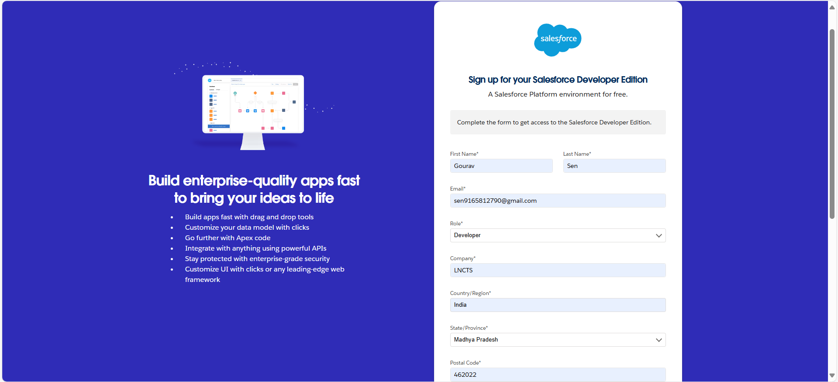**Steps**: Create a Salesforce developer account and activate it for project use.

**Object Creation**

* **Supplier Object**: Captures supplier details.
* **Rice Mill Object**: Tracks operations and inventory.
* **Consumer Object**: Records consumer information.
* A screenshot of a computer

  Description automatically generated**Rice Details Object**: Stores detailed information about rice transactions.

**Tabs Creation**

* A screenshot of a computer

  Description automatically generated**Steps**: Create custom tabs for each object to enable easy navigation.

**The Lightning App**

* 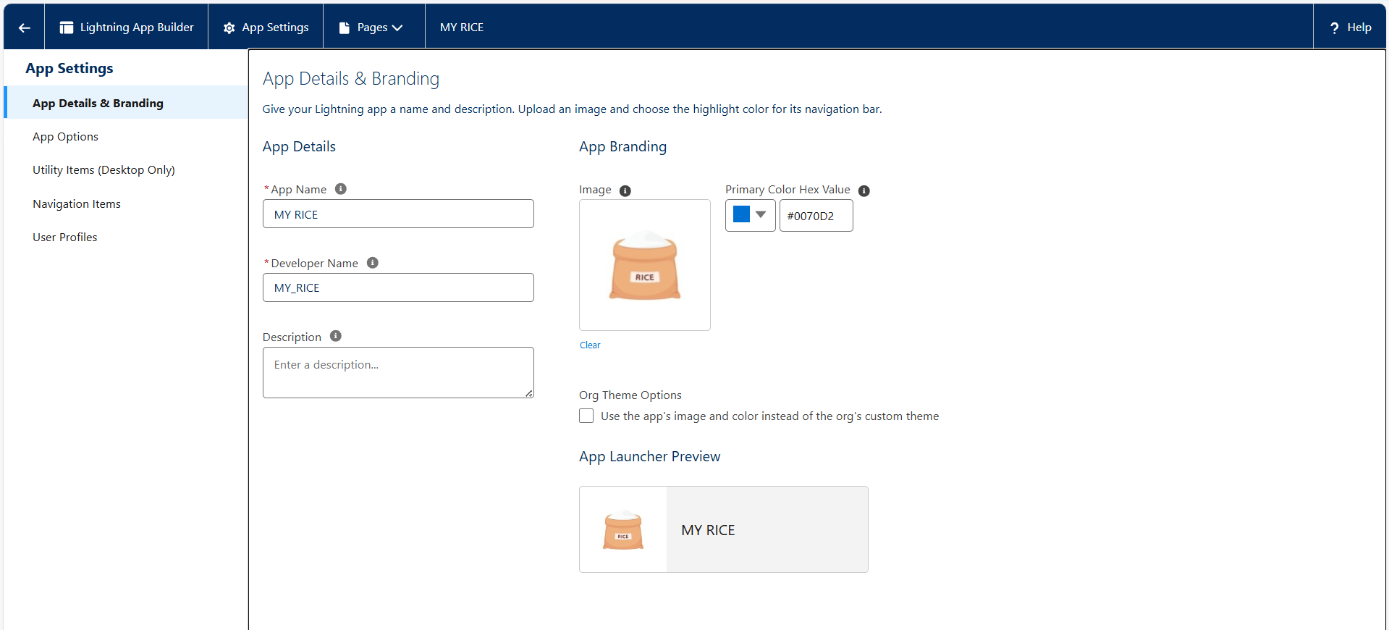**Steps**: Set up a Lightning App to organize the Rice Mill CRM and its components.

**Field Creation**

* **Number Field in Rice Details Object**: Tracks the quantity of rice.
* **Junction Object**: Establishes relationships between Rice Mill and other objects.
* **Master-Detail Relationship**: Links objects like Consumers and Rice Details.
* **Roll-Up Summary**: Aggregates rice quantities from related records.
* 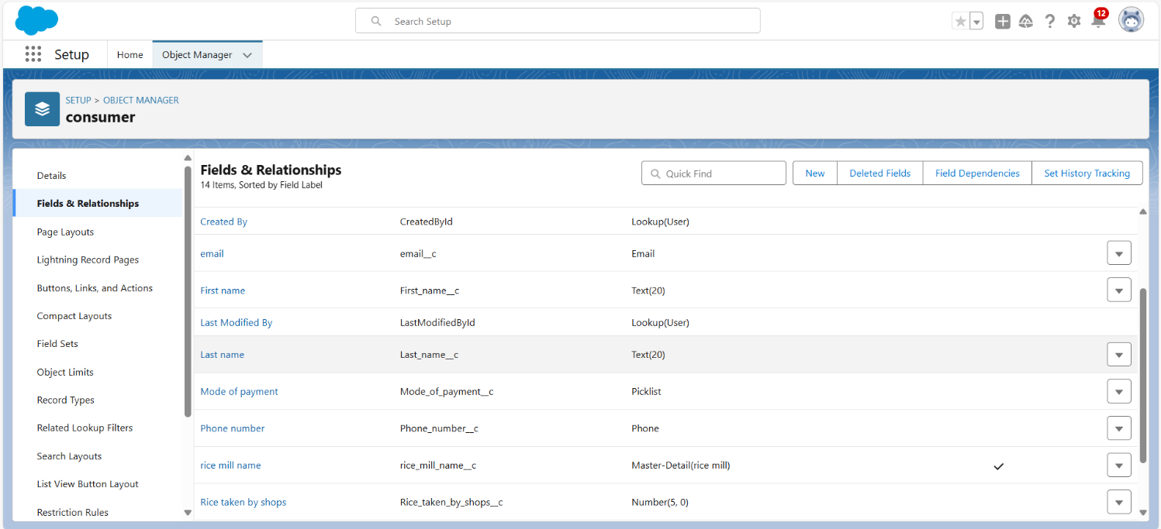**Cross-Object Formula Field**: Calculates payments in Consumer records.
* 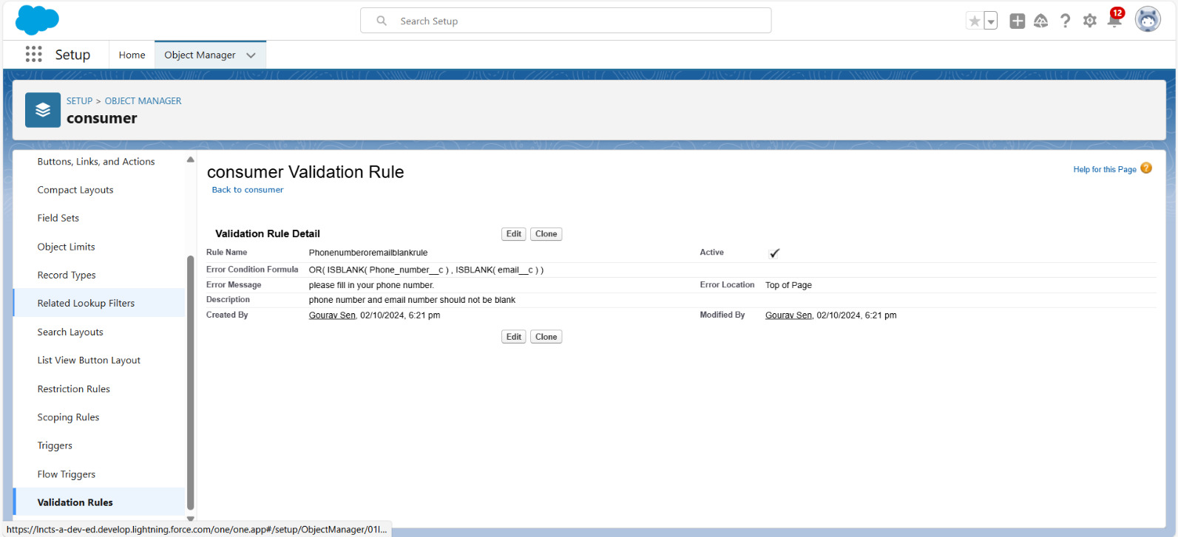**Validation Rule**: Ensures required fields are filled out.

**Page Layouts**

* A screenshot of a computer

  Description automatically generated**Steps**: Customize page layouts to streamline data entry and display for various profiles.

**Profiles and Roles**

* **Owner Profile**: Full access to all data and functionalities.
* **Employer Profile**: Access to Worker data and limited access to other records.
* **Worker Profile**: Restricted access, primarily to their own data.

**Users and Permission Sets**

* **OWD Setting**: Configured to restrict access based on organizational roles.
* A screenshot of a computer

  Description automatically generated**User Creation**: Set up users for different roles and assign permission sets accordingly.

**Reports and Dashboards**

* **Report Creation**: Design reports to summarize daily sales and other key metrics.

* 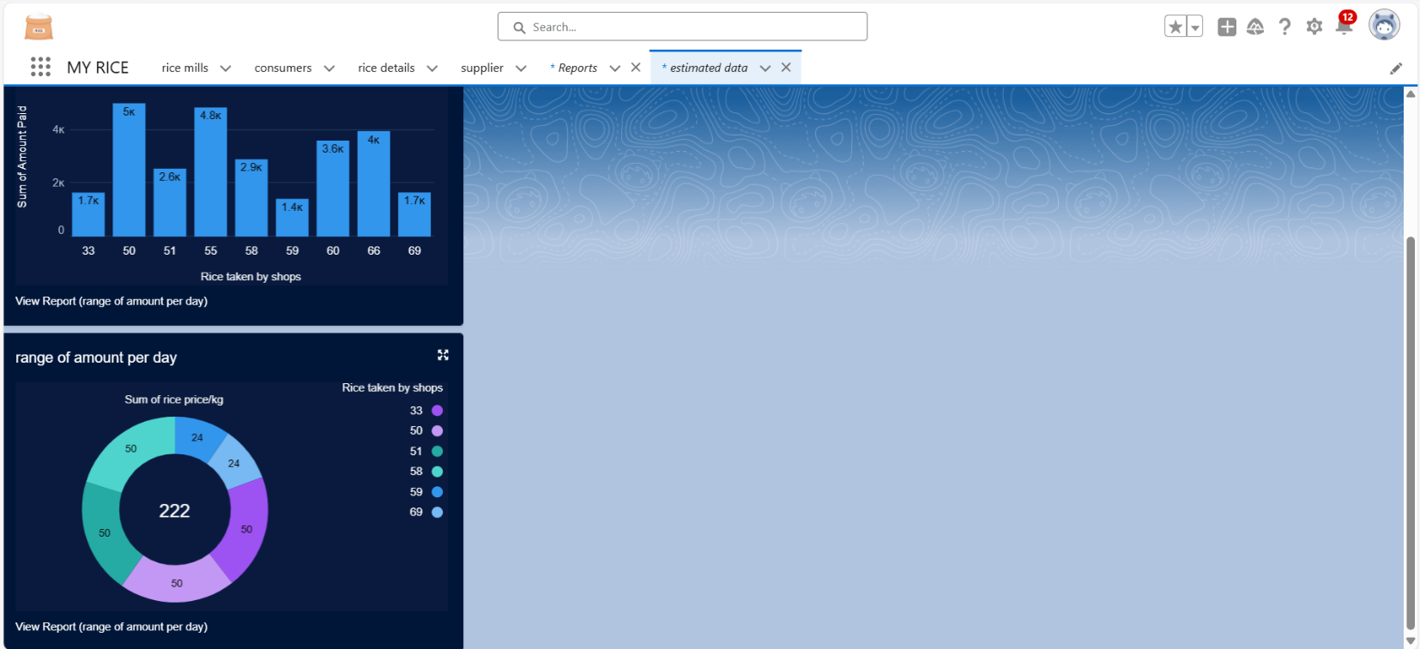**Dashboard Setup**: Create dashboards to visualize data for quick insights.

**Apex Development**

* A screenshot of a computer

  Description automatically generated**Apex Class (ConsumerRecord)**: Manages operations related to Consumer records.
* A screenshot of a computer

  Description automatically generated**Apex Trigger**: Automates processes, such as updating related records when Consumer records are modified.

# 6.What I Gained from the Project

Building the Rice Mill CRM Application has been an incredible journey. Here’s what I’ve accomplished and learned:

* **Hands-On Salesforce Experience**: I gained valuable experience configuring and customizing CRM applications on Salesforce, building a system tailored to the needs of a rice mill. This included setting up objects, fields, and relationships.
* **Understanding Objects & Relationships**: I learned to create and manage custom objects like Suppliers, Rice Mills, Consumers, and Rice Details, understanding how they interrelate to form an effective CRM system.
* **Developing Formula Fields and Validation Rules**: I crafted formula fields to calculate payments and implemented validation rules to ensure data integrity, preventing incorrect or incomplete records.
* **Applying Cross-Object Formula Fields**: I used cross-object formula fields to pull information from related records, allowing for essential calculations and data aggregation.
* **Designing Page Layouts**: I customized page layouts to make the application user-friendly, arranging fields and sections for easy access to data.
* **Using Rollup Summary Fields**: I implemented rollup summaries to aggregate data from child records and display it on parent records, improving inventory management.
* **Creating Reports and Dashboards**: I developed reports and dashboards to track daily sales, revenue, and popular rice types, providing valuable insights for decision-making.

Overall, this project significantly enhanced my Salesforce skills and resulted in a practical tool to improve rice mill management.

# 7.Conclusion

Reflecting on the development of the Rice Mill CRM Application, I’m very satisfied with what I’ve achieved. This project has been a valuable learning experience, helping me apply and expand my Salesforce skills in a practical setting.

By building this CRM system, I’ve gained hands-on expertise with key Salesforce features like object creation, formula fields, and validation rules. I also learned how to design intuitive page layouts and use rollup summary fields to simplify data management. Creating customized reports and dashboards has allowed me to visualize key metrics and generate meaningful insights.

Looking forward, I’m excited about future enhancements. Whether it’s adding advanced reporting, integrating with external systems, or incorporating AI-driven analytics, there’s significant potential to further improve the CRM. I’m also keen on enhancing data security and expanding user support and training to meet the rice mill’s evolving needs.

Overall, this project has sharpened my technical skills and produced a practical tool that positively impacts rice mill operations. I’m proud of the progress made and optimistic about the continued growth and value of this CRM application.

# 8.Future Enhancements

Looking ahead, there are several exciting opportunities to enhance the Rice Mill CRM Application. Here’s what I’m envisioning:  
● **Advanced Reporting Capabilities**: There’s potential to dive deeper into data by adding features like custom report filters, scheduled email updates, and interactive dashboards. This could help users better track rice sales and customer trends. Imagine detailed sales patterns over time or automatic reports on key metrics—this would make decision-making much smoother.  
● **Integration with External Systems**: Seamless integration with external systems like accounting software or inventory tools could be transformative. It would eliminate manual data entry and keep financial records and inventory levels in sync.  
● **Enhanced User Interface and Experience**: Improving the interface to be more intuitive, adding customizable dashboard widgets, and ensuring mobile compatibility would make the CRM more user-friendly and efficient for all users.  
● **Automated Workflows and Notifications**: Setting up automated workflows and notifications can streamline operations. For example, automatic reminders for payment deadlines or inventory restocking would help avoid missed tasks and keep things running smoothly.  
● **Integration of AI and Analytics**: The future holds promise with AI and advanced analytics. Tools that predict trends, spot issues, or analyze customer behavior could lead to smarter decision-making and help anticipate market changes.  
● **Expanded User Training and Support**: To ensure everyone uses the CRM to its full potential, providing detailed user guides, video tutorials, and a support helpdesk would instill confidence and assist users in navigating the application.

These enhancements aim to make the CRM more powerful and user-friendly, and I’m excited to see how they will further optimize the rice mill's operations and drive business growth.

# 